Building a Relational Media Production & Asset Management Dashboard

Objective
To build a relational database application using Python, SQLite and Tkinter to manage studios, productions and media assets. The application demonstrates primary keys,
foreign keys, cascading deletes, data validation, insertion, deletion, SQL JOIN operations and live table refreshes.

Import the required libraries
The sqlite3 module connects Python to SQLite. Tkinter and its ttk module are used to create the graphical interface. messagebox displays validation and confirmation
messages.

In [ ]:
import sqlite3
import tkinter as tk
from tkinter import ttk, messagebox
from datetime import datetime
from contextlib import contextmanager
import math

DB_NAME = "media_management.db"

print("Libraries imported successfully.")

Create the database and relational tables
Three tables are created:
  - studios : stores studio details.
  - productions : stores productions and the studio they belong to.
  - media_assets : stores assets and the production they belong to.
Foreign-key enforcement is enabled on every database connection. ON DELETE CASCADE ensures that deleting a studio also deletes its productions and assets, and deleting a production also deletes its assets.

In [ ]:
@contextmanager
def get_connection():
"""Create a SQLite connection with foreign keys enabled and safe cleanup.""" connection = sqlite3.connect(DB_NAME)
connection.execute("PRAGMA foreign_keys = ON")
try:
yield connection
connection.commit()

except Exception:
connection.rollback()
raise finally:
connection.close()

def create_tables():
"""Create the three related tables if they do not already exist."""
with get_connection() as conn: conn.execute("""
CREATE TABLE IF NOT EXISTS studios (
studio_id INTEGER PRIMARY KEY AUTOINCREMENT,
studio_name TEXT NOT NULL UNIQUE, email TEXT NOT NULL
) """)
conn.execute("""
CREATE TABLE IF NOT EXISTS productions (
production_id INTEGER PRIMARY KEY AUTOINCREMENT,
studio_id INTEGER NOT NULL,
production_title TEXT NOT NULL, release_date TEXT NOT NULL,
FOREIGN KEY (studio_id)
REFERENCES studios(studio_id) ON DELETE CASCADE
) """)
conn.execute("""
CREATE TABLE IF NOT EXISTS media_assets (
asset_id INTEGER PRIMARY KEY AUTOINCREMENT,
production_id INTEGER NOT NULL, asset_type TEXT NOT NULL,
asset_duration REAL NOT NULL CHECK (asset_duration >= 0), FOREIGN KEY (production_id)
REFERENCES productions(production_id) ON DELETE CASCADE
) """)
print("Database and all three tables are ready.")

create_tables()

Seed the database with sample records
Sample records are inserted only if all three tables are empty. If records already exist, the notebook leaves the database unchanged. This prevents sample data from being duplicated each time the notebook is run.

In [ ]:
def seed_database():
"""Insert sample data only when all three tables are completely empty.""" with get_connection() as conn:
counts = [
conn.execute(f"SELECT COUNT(*) FROM {table}").fetchone()[0]
for table in ("studios", "productions", "media_assets")
]

if counts == [0, 0, 0]: sample_studios = [
("Dream Studios", "dream@example.com"), ("Star Productions", "star@example.com"), ("Vision Media", "vision@example.com")
]
studio_ids = {}
for name, email in sample_studios: cursor = conn.execute(
"INSERT INTO studios (studio_name, email) VALUES (?, ?)", (name, email)
)
studio_ids[name] = cursor.lastrowid

sample_productions = [
("Dream Studios", "The Lost World", "2026-01-15"), ("Star Productions", "Future Dreams", "2026-03-20"), ("Vision Media", "Ocean Life", "2026-05-10")
]
production_ids = {}
for studio_name, title, release_date in sample_productions: cursor = conn.execute(
"""INSERT INTO productions
(studio_id, production_title, release_date) VALUES (?, ?, ?)""",
(studio_ids[studio_name], title, release_date)
)
production_ids[title] = cursor.lastrowid

sample_assets = [
("The Lost World", "Trailer", 2.5), ("The Lost World", "Episode", 45), ("Future Dreams", "Promo", 1.5),
("Ocean Life", "Trailer", 3)
]
for title, asset_type, duration in sample_assets: conn.execute(
"""INSERT INTO media_assets
(production_id, asset_type, asset_duration) VALUES (?, ?, ?)""",
(production_ids[title], asset_type, duration)
)
print("Sample records inserted successfully.")
else:
print("The database is not completely empty. Sample data was not ins

seed_database()

Define database operations
The functions below perform insertion, deletion and data retrieval. Parameterized SQL queries ( ? ) are used when values are supplied by the user.
When a studio already exists, its existing ID is reused. Otherwise, a new studio is created. Every successful form submission then creates one production and one media asset.

In [4]:
def add_record(studio_name, email, production_title, release_date, asset_type, d """Reuse or create a studio, then add one production and one asset atomicall studio_name = studio_name.strip()
email = email.strip()
production_title = production_title.strip() release_date = release_date.strip()
asset_type = asset_type.strip()

with get_connection() as conn: row = conn.execute(
"SELECT studio_id FROM studios WHERE studio_name = ? COLLATE NOCASE" (studio_name,)
).fetchone()

if row:
studio_id = row[0]

else:
cursor = conn.execute(
"INSERT INTO studios (studio_name, email) VALUES (?, ?)", (studio_name, email)

)
studio_id = cursor.lastrowid

cursor = conn.execute(
"""INSERT INTO productions
(studio_id, production_title, release_date) VALUES (?, ?, ?)""",
(studio_id, production_title, release_date)
)
production_id = cursor.lastrowid

conn.execute(
"""INSERT INTO media_assets
(production_id, asset_type, asset_duration) VALUES (?, ?, ?)""",
(production_id, asset_type, duration)
)

return production_id

def delete_studio(studio_id):
with get_connection() as conn:
conn.execute("DELETE FROM studios WHERE studio_id = ?", (studio_id,))

def delete_production(production_id):
with get_connection() as conn:
conn.execute("DELETE FROM productions WHERE production_id = ?", (product

def delete_asset(asset_id):
with get_connection() as conn:
conn.execute("DELETE FROM media_assets WHERE asset_id = ?", (asset_id,))

def fetch_all(query, params=()):
with get_connection() as conn:
return conn.execute(query, params).fetchall()

print("Database operation functions are ready.")
Database operation functions are ready.

Define the combined JOIN query
The combined view joins the three related tables. It displays the production ID, studio name, production title, release date, asset type and asset duration in one view.

In [5]:
JOIN_QUERY = """ SELECT
p.production_id, s.studio_name,
p.production_title, p.release_date,
a.asset_type,
a.asset_duration FROM productions AS p
JOIN studios AS s ON p.studio_id = s.studio_id
JOIN media_assets AS a ON p.production_id = a.production_id ORDER BY p.production_id, a.asset_id
"""

print("Combined JOIN query is ready.")
print("Current combined records:", len(fetch_all(JOIN_QUERY)))

Combined JOIN query is ready. Current combined records: 4

Build the Tkinter dashboard
The dashboard contains:
  - Insert panel: accepts studio, production and asset details.
  - Delete panel: provides separate dynamic dropdowns for studios, productions and media assets.
  - Tabbed display: provides one combined JOIN view and three raw table views.
After every successful insertion or deletion, the application refreshes all four tables and all dropdowns. Deleted IDs are therefore removed from the dropdown choices.

In [ ]:
# Create the main application window
root = tk.Tk()
root.title("Media Production & Asset Management Dashboard") root.geometry("1250x800")
root.minsize(950, 650)

# Main container
main_frame = ttk.Frame(root, padding=12) main_frame.pack(fill="both", expand=True)

title_label = ttk.Label( main_frame,

text="Media Production & Asset Management Dashboard", font=("Arial", 18, "bold")
)
title_label.pack(pady=(0, 12))

# INSERT PANEL
insert_frame = ttk.LabelFrame(main_frame, text="Insert Panel", padding=10) insert_frame.pack(fill="x", pady=6)

field_frame = ttk.Frame(insert_frame) field_frame.pack(fill="x")

studio_name_var = tk.StringVar() email_var = tk.StringVar()
production_title_var = tk.StringVar() release_date_var = tk.StringVar()
asset_type_var = tk.StringVar() duration_var = tk.StringVar()

fields = [
("Studio Name", studio_name_var), ("Studio Email", email_var),
("Production Title", production_title_var),
("Release Date (YYYY-MM-DD)", release_date_var), ("Asset Type", asset_type_var),
("Asset Duration (minutes)", duration_var)
]

for index, (label_text, variable) in enumerate(fields): row = index // 3
col = (index % 3) * 2

ttk.Label(
field_frame,
text=label_text
).grid(row=row, column=col, padx=5, pady=5, sticky="w")

ttk.Entry(
field_frame,
textvariable=variable, width=27
).grid(row=row, column=col + 1, padx=5, pady=5, sticky="ew")

for col in range(6):
field_frame.columnconfigure(col, weight=1)

def clear_insert_fields():
for variable in (
studio_name_var, email_var,
production_title_var, release_date_var,
asset_type_var, duration_var
):
variable.set("")

def handle_add_record():

studio_name = studio_name_var.get().strip() email = email_var.get().strip()
production_title = production_title_var.get().strip() release_date = release_date_var.get().strip()
asset_type = asset_type_var.get().strip() duration_text = duration_var.get().strip()

# Reject blank fields
if not all([
studio_name, email,
production_title, release_date,
asset_type, duration_text
]):
messagebox.showwarning(
"Missing Information",
"Please fill in all fields."
)

return

# Basic email validation
if "@" not in email or "." not in email.split("@")[-1]: messagebox.showwarning(
"Invalid Email",
"Please enter a valid email address."
)

return

# Validate date format
try:
datetime.strptime(release_date, "%Y-%m-%d")

except ValueError:
messagebox.showwarning( "Invalid Date",
"Enter the release date in YYYY-MM-DD format."
)

return

# Validate numeric, non-negative duration
try:
duration = float(duration_text)

if not math.isfinite(duration) or duration < 0:
raise ValueError

except (ValueError, TypeError, OverflowError): messagebox.showwarning(
"Invalid Duration",
"Duration must be a numeric value greater than or equal to zero."
)

return

# Insert record into database
try:
production_id = add_record(

studio_name, email,
production_title, release_date,
asset_type, duration
)

clear_insert_fields() refresh_all()

messagebox.showinfo( "Success",
f"Record added successfully.\nNew Production ID: {production_id}"
)

except sqlite3.Error as error: messagebox.showerror(
"Database Error", str(error)
)

add_button = ttk.Button( insert_frame,
text="Add Record",
command=handle_add_record
)
add_button.pack(pady=(8, 2))

# DELETE PANEL
delete_frame = ttk.LabelFrame(main_frame, text="Delete Panel", padding=10) delete_frame.pack(fill="x", pady=6)

studio_choice = tk.StringVar()
production_choice = tk.StringVar() asset_choice = tk.StringVar()

studio_combo = ttk.Combobox( delete_frame,
textvariable=studio_choice, state="readonly",
width=35
)

production_combo = ttk.Combobox( delete_frame,
textvariable=production_choice, state="readonly",
width=35
)

asset_combo = ttk.Combobox( delete_frame,
textvariable=asset_choice, state="readonly",
width=35
)

delete_items = [
("Studio", studio_combo, studio_choice),
("Production", production_combo, production_choice), ("Media Asset", asset_combo, asset_choice)
]
for col, (label_text, combo, variable) in enumerate(delete_items): ttk.Label(
delete_frame,
text=f"Select {label_text}"
).grid(row=0, column=col, padx=8, pady=4, sticky="w")

combo.grid(
row=1,
column=col, padx=8,
pady=4,
sticky="ew"
)

delete_frame.columnconfigure(col, weight=1)

def selected_id(choice):

value = choice.get().strip()

if not value:

return None

try:
return int(value.split(" - ", 1)[0])

except (ValueError, IndexError):

return None

def handle_delete_studio():

studio_id = selected_id(studio_choice)

if studio_id is None:
messagebox.showwarning( "Selection Required",
"Select a studio to delete."
)

return

if messagebox.askyesno( "Confirm Delete",
"Delete this studio and ALL its productions and media assets?"
):
try:
delete_studio(studio_id) refresh_all()

messagebox.showinfo( "Success",
"Studio and its related records deleted."

)

except sqlite3.Error as error:
messagebox.showerror("Database Error", str(error))

def handle_delete_production():

production_id = selected_id(production_choice)

if production_id is None: messagebox.showwarning(
"Selection Required",
"Select a production to delete."
)

return

if messagebox.askyesno( "Confirm Delete",
"Delete this production and all its media assets?"
):
try:
delete_production(production_id) refresh_all()

messagebox.showinfo( "Success",
"Production and its assets deleted."
)

except sqlite3.Error as error:
messagebox.showerror("Database Error", str(error))

def handle_delete_asset():

asset_id = selected_id(asset_choice)

if asset_id is None:
messagebox.showwarning( "Selection Required",
"Select a media asset to delete."
)

return

if messagebox.askyesno( "Confirm Delete",
"Delete only this media asset?"
):
try:
delete_asset(asset_id) refresh_all()

messagebox.showinfo( "Success",
"Media asset deleted. Its production and studio remain."
)

except sqlite3.Error as error:
messagebox.showerror("Database Error", str(error))

ttk.Button(
delete_frame,
text="Delete Studio",
command=handle_delete_studio
).grid(row=2, column=0, padx=8, pady=8, sticky="ew")

ttk.Button(
delete_frame,
text="Delete Production",
command=handle_delete_production
).grid(row=2, column=1, padx=8, pady=8, sticky="ew")

ttk.Button(
delete_frame,
text="Delete Media Asset", command=handle_delete_asset
).grid(row=2, column=2, padx=8, pady=8, sticky="ew")

# ---------- TABBED DISPLAY PANEL ----------
display_frame = ttk.LabelFrame( main_frame,
text="Tabbed Database Display", padding=8
)
display_frame.pack(fill="both", expand=True, pady=6)

notebook = ttk.Notebook(display_frame) notebook.pack(fill="both", expand=True)

tab_definitions = [ (
"Combined JOIN View", (
"Production ID", "Studio Name",
"Production Title", "Release Date",
"Asset Type",
"Asset Duration"
)
), (
"Studios",
("Studio ID", "Studio Name", "Email")
), (
"Productions",
("Production ID", "Studio ID", "Production Title", "Release Date")
), (
"Media Assets",
("Asset ID", "Production ID", "Asset Type", "Asset Duration")
)
]

treeviews = {}

for tab_name, columns in tab_definitions:

tab = ttk.Frame(notebook, padding=5) notebook.add(tab, text=tab_name)

tree = ttk.Treeview( tab,
columns=columns, show="headings"
)

for column in columns:
tree.heading(column, text=column) tree.column(
column,
width=150, minwidth=90,
anchor="center"
)

vertical_scroll = ttk.Scrollbar( tab,
orient="vertical", command=tree.yview
)

horizontal_scroll = ttk.Scrollbar( tab,
orient="horizontal", command=tree.xview
)

tree.configure(
yscrollcommand=vertical_scroll.set, xscrollcommand=horizontal_scroll.set
)

tree.grid(row=0, column=0, sticky="nsew")
vertical_scroll.grid(row=0, column=1, sticky="ns")
horizontal_scroll.grid(row=1, column=0, sticky="ew")

tab.rowconfigure(0, weight=1)
tab.columnconfigure(0, weight=1) treeviews[tab_name] = tree

def populate_tree(tree, rows):

for item in tree.get_children(): tree.delete(item)

for row in rows:
tree.insert("", "end", values=row)

def refresh_all():

"""Refresh all four views and all delete dropdowns."""

combined_rows = fetch_all(JOIN_QUERY)

studios = fetch_all(
"SELECT studio_id, studio_name, email FROM studios ORDER BY studio_id"
)

productions = fetch_all(
"""SELECT production_id, studio_id, production_title, release_date FROM productions ORDER BY production_id"""
)

assets = fetch_all(
"""SELECT asset_id, production_id, asset_type, asset_duration FROM media_assets ORDER BY asset_id"""
)

# Refresh all four tables
populate_tree(
treeviews["Combined JOIN View"], combined_rows
)

populate_tree(
treeviews["Studios"], studios
)

populate_tree(
treeviews["Productions"], productions
)

populate_tree(
treeviews["Media Assets"], assets
)

# Update dropdown values
studio_values = [
f"{row[0]} - {row[1]}" for row in studios
]

production_values = [
f"{row[0]} - {row[2]}" for row in productions
]

asset_values = [
f"{row[0]} - {row[2]} (Production {row[1]})"
for row in assets
]

studio_combo["values"] = studio_values
production_combo["values"] = production_values asset_combo["values"] = asset_values

# Clear selections after refresh
studio_choice.set("")
production_choice.set("") asset_choice.set("")

#
INITIAL DISPLAY
refresh_all()

print("Dashboard is ready. The Tkinter window will open now.")

# Start GUI event loop
root.mainloop()

Test the application
Run the dashboard and check each requirement:
- Added a record for a new studio.
- Added another production using the same studio name. The existing studio ID should be reused.
- Tried submitting blank fields.
- Tried a negative duration, non-numeric duration, nan and inf .
- Deleted one media asset and verify that its production and studio remain.
- Deleted a production and verify that its assets disappear.
- Deleted a studio and verify that all its productions and assets disappear.
- After each operation, checked that all four tabs and the dropdowns refresh and no deleted ID remains selected. THESE TASKS WERE PERFORMED

Conclusion
The application uses a relational SQLite database with three linked tables. Primary keys and foreign keys maintain relationships, while cascading deletes prevent orphaned
production and asset records. The Tkinter interface supports adding and deleting
records, validates user input, and refreshes the combined JOIN view and individual table views after database changes.

In [ ]:

Output:

Media Production and Asset Management Dashboard

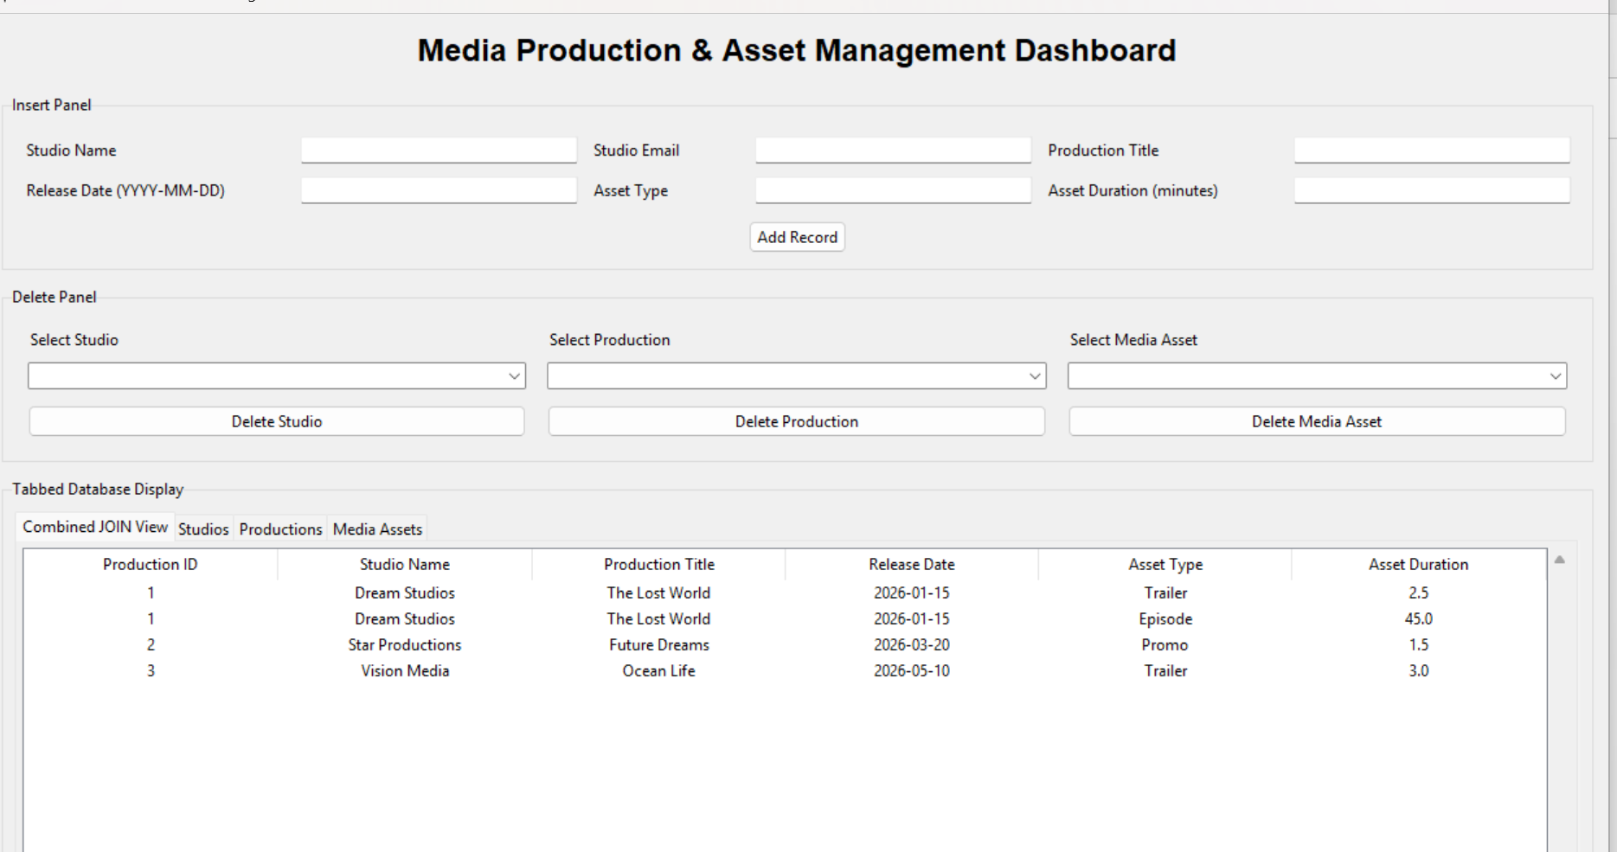

Combined JOIN View

Studios Table

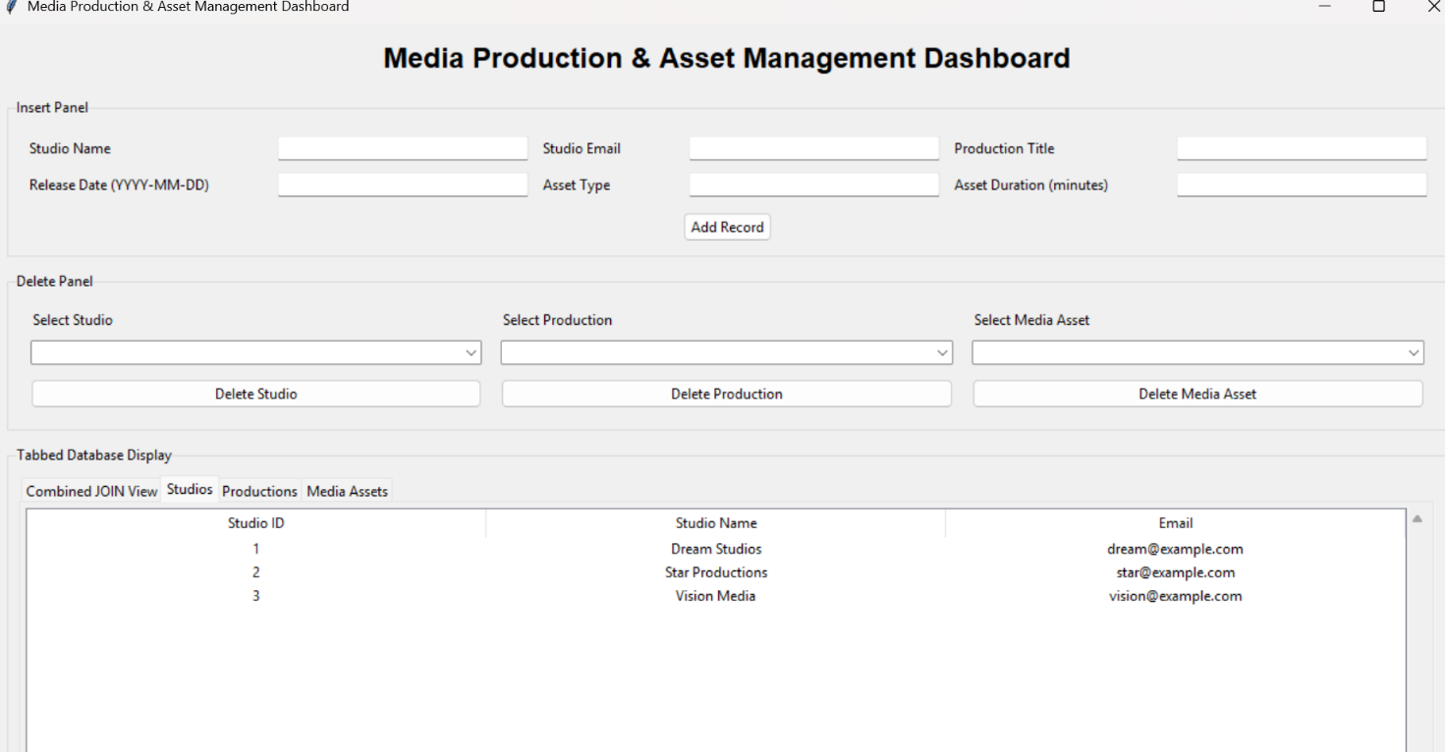

Productions Table

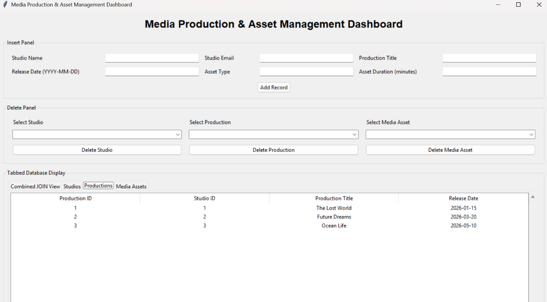

Media Assets Table

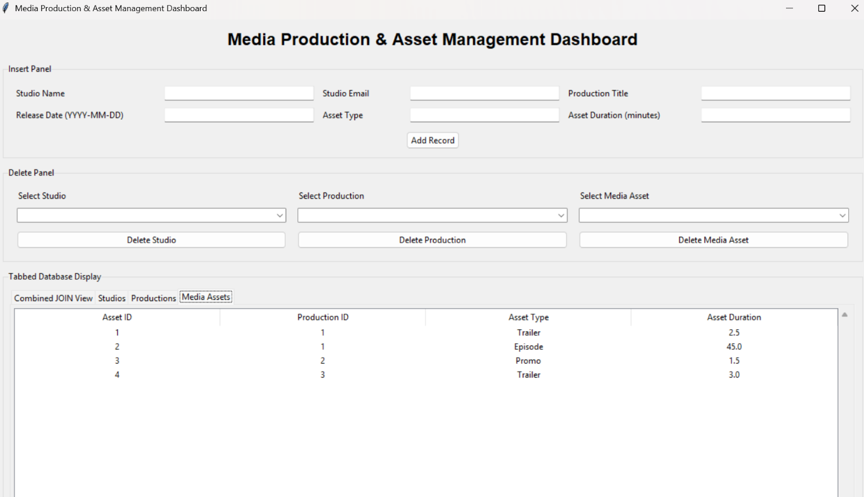

Blank Field Validation

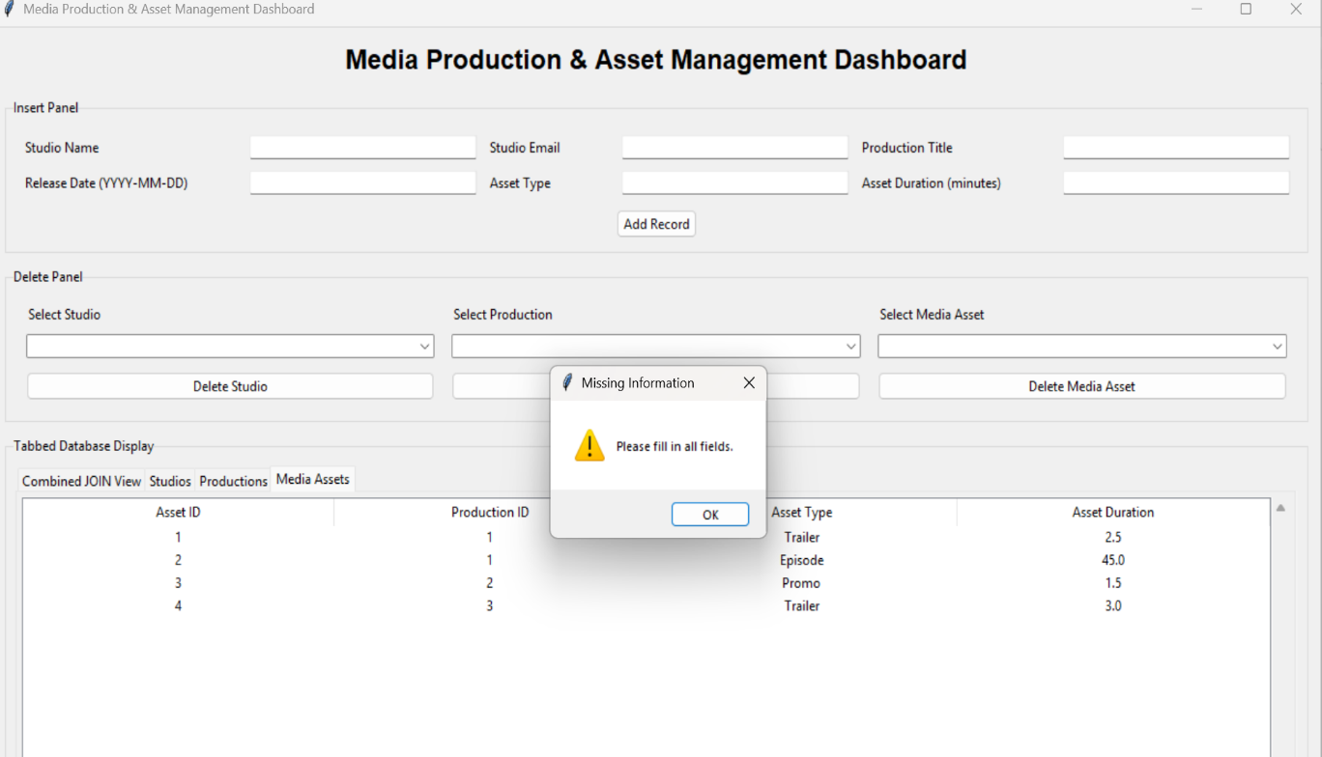

Invalid Email Validation

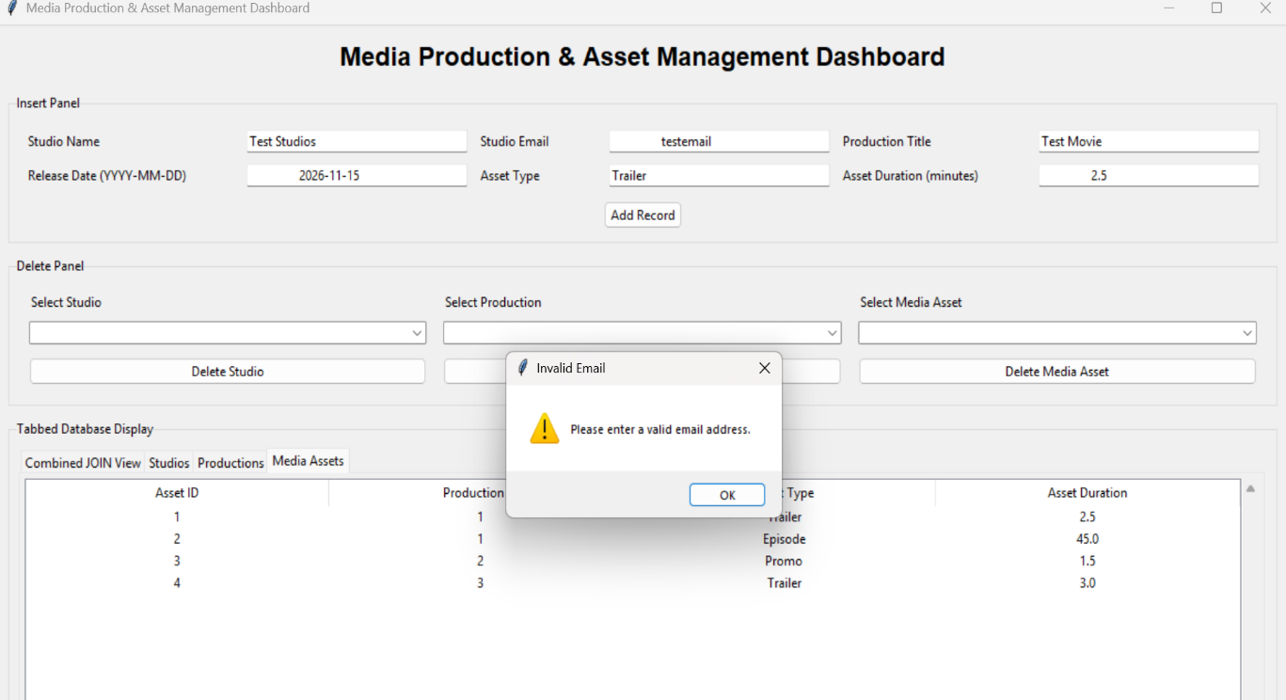

Invalid Date Validation

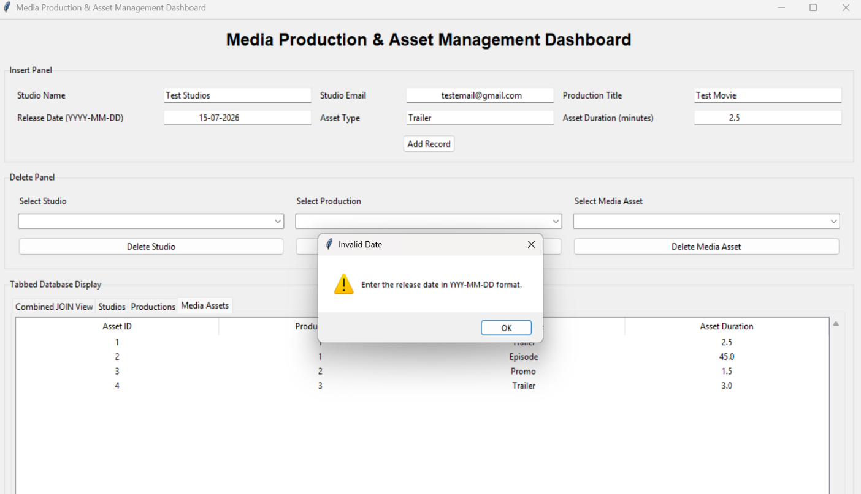

Invalid Duration Validation

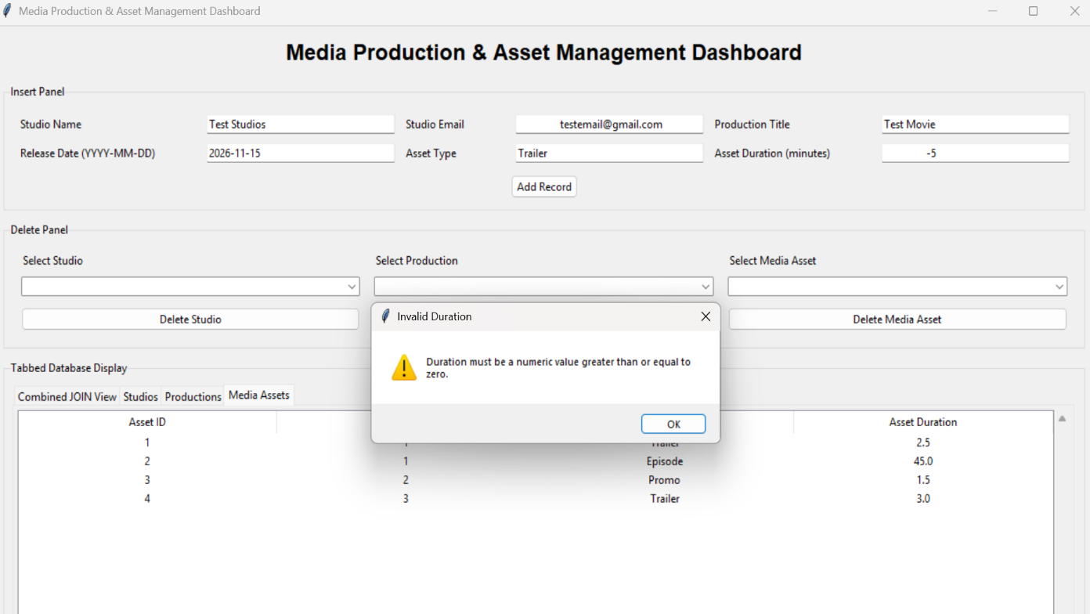

Production Media deletion

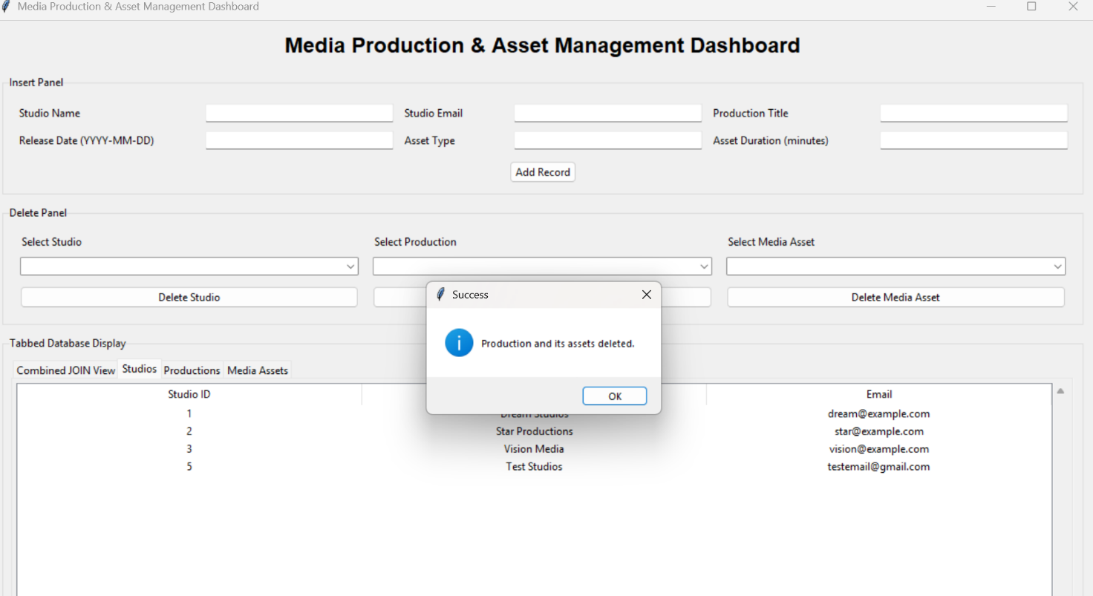

Studio media deletion

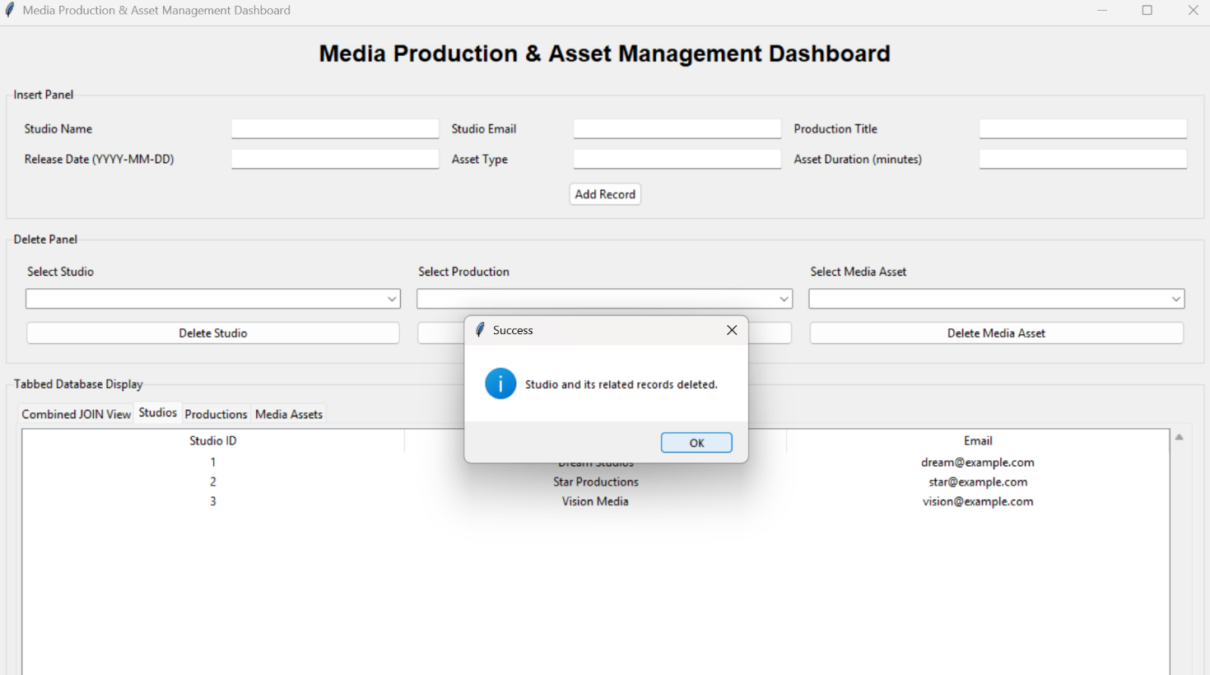

New record added

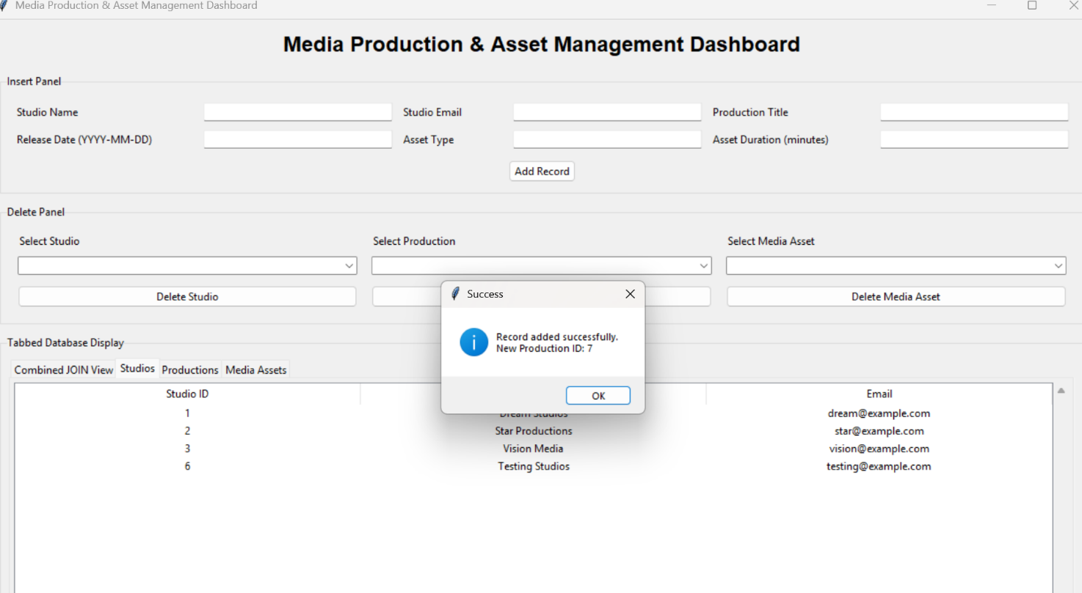

Combined join view

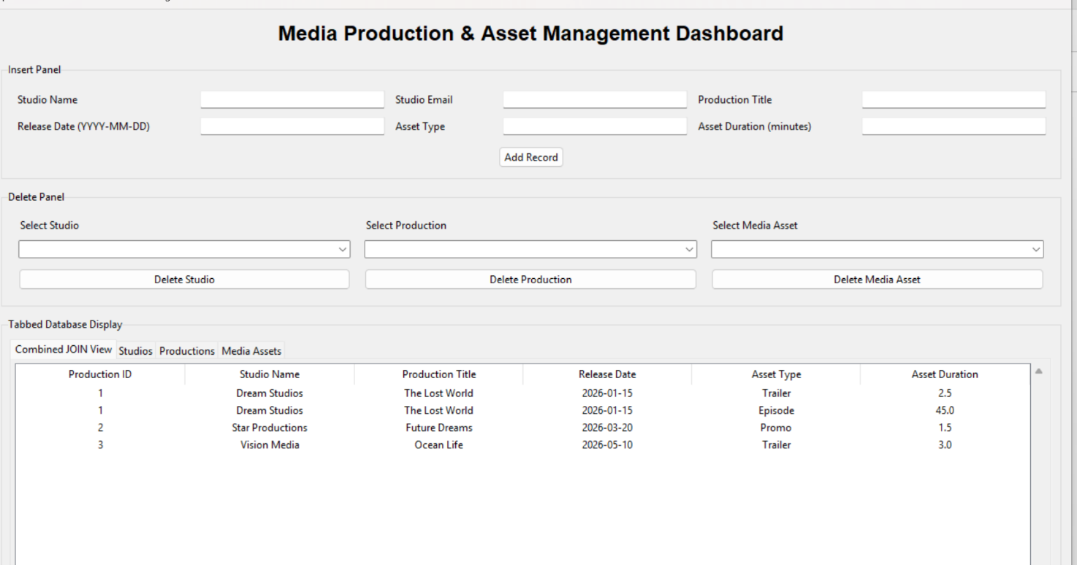

Production test production 2 deleted



